

Enterprise Web Software Development

INDIVIDUAL Report

Term 2 - MAC

Learner’s name: Nguyen Quang Vinh

Greenwich Course Leader: Mr. Matthew Prichard

Name of the reporter: Nguyen Quang Vinh

Class: TCS2006

Learner’s ID: TCS19023

Subject’s ID: 1640

Assignment due: 7th May 2020

Assignment submitted: 29t

**ASSIGNMENT BRIEF**

|  |  |  |  |
| --- | --- | --- | --- |
| **Qualification** | **Honours Diploma in Computing** | | |
| **Unit number** | Term 2 – Level 6 – CW – COMP1640 | | |
| **Assignment title** | Enterprise Web Software Development | | |
| **Academic Year** | 2019 – 2020 | | |
| **Unit Tutor** |  | | |
| **Issue date** |  | **Submission date** |  |
| **IV name and date** |  | | |

Contents

**Preface** 2

Abstract 2

Professional Background 2

Interdisciplinary collaboration 3

Competence Triangle 3

Diversities in the Group 3

Expectations on this project 4

Group Dynamics and Team Development 5

Differently the Roles 5

**Evaluation of product and process** 12

Database Design Screen Shots 12

Interface Design Screen shot 13

Backend Coding 13

Upload Function 13

Export Function 14

Import Function 14

Data Flow Explanation 14

How we process the current Project using Agile 15

Evaluative the product 15

Evaluative the Agile process 15

Personal unsatisfied points of view 16

How to improve 16

**Evaluation of Team** 17

**Self-Evaluation** 18

**SCREENCAST & PRESENTATION** 19

**LOCATION REPOSITORY** 19

TABLE OF FIGURES

Figure 1: Agile Project Plan Template - Nguyen Quang Vinh 7

Figure 2: Agile Project Plan Template - Dinh Thi Lan Hue 8

Figure 3: Agile Project Plan Template - Le Thanh Trung 9

Figure 4: Agile Project Plan Template – Lu Thua Thong 10

Figure 5: Agile Project Plan Template - Dao Van Hieu 11

Figure 6: Agile Project Plan Template - Le Thanh Phong 12

Figure 7: Database Design Example 13

Figure 8: Mockup Example 14

Figure 9: Upload Function 14

Figure 10: Export Function 1 15

Figure 11: Export Function 2 15

Figure 12: Import Function 15

Figure 13: Agile Scrum method 18

Figure 14: Factor Comparison 20

# **Preface**

This project was built to fit with the requirement from the stakeholders, they want a web application that can handle the role-based system for a large university. It takes 8 weeks to make this web application, or close to 60 hours of working for a person if this is a six members team like my team. Since it need to adopt agile scrum working practices, working close to a team to maintain the communication is essential, but then the pandemic hit the world and make it really hard to meet up face-to-face.

I want to say thank to all members of my team, who already help me finish this project, and also the thank to Mr. Thanh – the instructor - who guide me on this one.

# **Abstract**

During the Hit of Covid-19, our team is under the quarantine for the whole semester and cannot meet others anywhere beside using Google Classroom. Not being meet up face-to-face is the huge disadvantage since some of the senses can not be transmit through the internet line. But I personally think that everyone just did their best to overcome the obstacle and finish the project beautifully. This project required us to work with a team while maintain the communicate and adopt Agile-Scrum as the way to develop the web application. The technical problem can be got over easily but how about the human adversity?

# **Professional Background**

This is the group of 6 members, was made up from the people from the class, and inside that:

* Mr. Le Hong Phong – familiar when working with React Native, using Java as programing language due to his work, and he is also the leader of our team since he had a lot of working experience (with a team) on his profile.
* Ms. Dinh Thi Lan Hue – used to work as web designer and also frontend developer, currently working full-time at a company in Ho Chi Minh City. She also had knowledge on design pattern and algorithm in the past.
* Mr. Dao Van Hieu – can go well with writing a program with Java and have a lot of working experience.
* Mr. Lu Thua Thong – He is really good at planning, that is why he is on the team since we will need to plan a lot because of the requirement of the current project – “adopted agile scrum method development” –
* Mr. Le Thanh Trung – His knowledge about foreign working cultural and his past certificated with coding made him stand out, it is hard to find someone who can both speak 3 different languages, working at an international company, had a lot of travel due to work, familiar with foreign working cultural as a team, and know how to code, he also used to create a web application in the past.
* And me – I myself have experience on database designer for a few projects in the past, used to carry on the whole project as full stack web developer, have background on C#, Java, Python, php, I also familiar with HTML, CSS, and know a little bit about JavaScript, but to be honest, I am a quite confident on design and build a database rather than coding, although I can using ASP.NET (C#) to create the application all by my own.

And as what being said, the most important thing is we are all come from different background and have different skill sets that will fit as a perfect developer team to work with and adopt agile scrum method without draw the other down – or so, I hope -

# **Interdisciplinary collaboration**

As the different on our professional background, we are both have difficulty on communicating since our personalities being sharp by our usual work cultural. As for Mr. Hieu, Mr. Phong and Ms. Hue, it is maybe easier for them to keep the work going, since they are both work for the coding companies, for Mr. Trung and Mr. Thong, I personally think they can catch up with the team after a while, since they are working for foreign companies and can adapt with the change on working environment, but it is quite hard for me to fit in since I am a sale person, my working field required to work alone all the time and carry on the whole thing is my normal day, I just hope I can change my habit and merge with the team quickly to contribute efficiency for the project.

## Competence Triangle

Since it is the mixed team of people come from different industrial fields, it is important to understand the strengths and weakness of each and everyone so that we can fill in the lacking of each other.

## Diversities in the Group

As I already said above, Mr. Hieu, Mr. Phong and Ms. Hue are used to working environment in the coding companies, they know how to work as a team, and more important, they understand really well what is Agile, what is Scrum, because they already work with it. They can carry out the work really efficiency if they have a proper and though through plan (and Yes, they already did it, I will talk about that later), I can say they have a lot of working experience when it come to work with Agile – Scrum.

In the other hand, I have no knowledge of what is Agile or what is Scrum, yes, I did learn about coding and a lot of coding languages before, and yes, I do carry out the projects on my own, but if I look back, all of them using Waterfall as the developing method since I am the only developer. Plus, I do not have much working experience as a team like Mr. Thong or Mr. Trung. That would be pretty hard for me to fit in the group to begin with.

Because of that, Mr. Phong – Our Leader – had a suggestion to have me work together with Mr. Thong and Mr. Trung most of the time, because I may learn how to adapt with the change from them and then fit with the team faster.

## Expectations on this project

For the group to move forward and the learning from this project, we must first plan out the “goals” or, being said, the “expectations” that we have on each member. It is just the “plan” so that we will know the milestones and how the process is going. The below is the expected we have on each member.

|  |  |
| --- | --- |
| ***Mr. Le Hong Phong*** | ***Ms. Dinh Thi Lan Hue*** |
| 1. Working well with the team 2. Working well with Agile - Scrum method 3. Helping with backend coding 4. Helping a part with frontend coding | 1. Working well with the team 2. Working well with Agile - Scrum method 3. Helping with backend coding 4. Working well with frontend coding |
| ***Mr. Le Thanh Trung*** | ***Mr. Lu Thua Thong*** |
| 1. Help Mr. Vinh to adapt with team 2. Working well with real time testing 3. Working well with backend coding 4. Working well with frontend design | 1. Help Mr. Vinh to adapt with team 2. Working well with real time testing 3. Working well with backend coding 4. Working well with frontend design |
| ***Mr. Nguyen Quang Vinh*** | ***Mr. Dao Van Hieu*** |
| 1. Learn how to adapt with the team 2. Working mainly on design frontend 3. Working mainly on design Database 4. Working mainly on build a Database 5. Working well with document after adapt with the development method 6. Help a part with backend coding | 1. Working well with the team 2. Working well with Agile - Scrum method 3. Helping with backend coding 4. Helping a part with frontend coding |

As the plan above, I expect to work really hard on this project since I must both learn to adapt with the team, and actually working with them to build the product to satisfy the requirement of the project.

# **Group Dynamics and Team Development**

## Differently the Roles

Because all members on our team is used to code, so the ideal is “made everyone the part of development team”. We decided to not let anyone carry just only one role, everyone will share the work equally, and of course, the one with stronger skill fit with any part of development process will mainly take care of this part and help the others also join in. For example, I really confident on my Database design and Frontend design, so I will take the main role on this part, but I will also help with the coding on backend development and with the document and record as a part of my learning teamwork from Mr. Trung and Mr. Thong. No one is left out at any part on the whole product development process.

For the better visualization, I can sum up my work as the table below

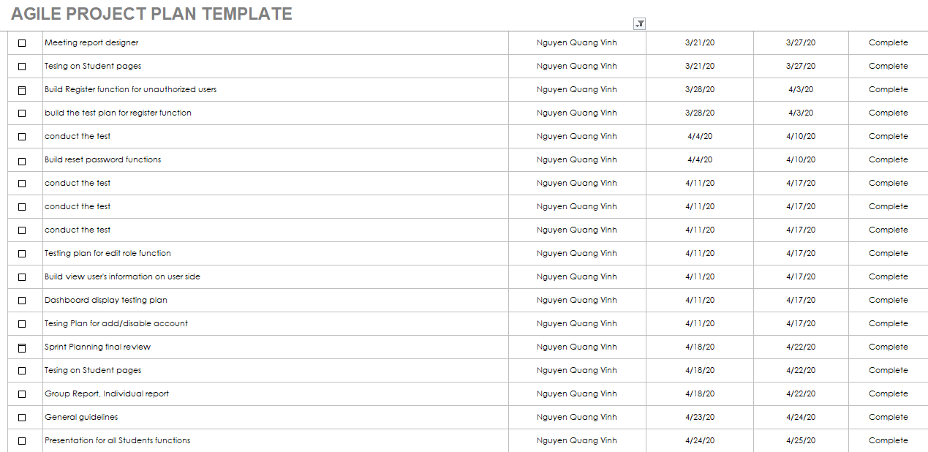

Figure 1: Agile Project Plan Template - Nguyen Quang Vinh

If this is too small, please take a look at the sprint_backlog and Daily_meeting files for more information

To sum it up, I:

* Working with Database Design on Sprint0 and build it successfully following the feedback from customer.
* Working with Interface Design on Sprint1 and build it successfully following the feedback from customer with the help from Ms. Hue.
* Working with backend coding, build Upload function, Import function, Export function, and implementing test on them on Sprint2 with the help from Ms. Hue, Mr. Phong, Mr. Hieu, and then modified it back to fit the requirements from customer.
* Finally, on Sprint3, I am planning the final review and write the Guideline for the website and then upload the source code to the online storage.

And this will be the works for others member as well

This is for Ms. Hue

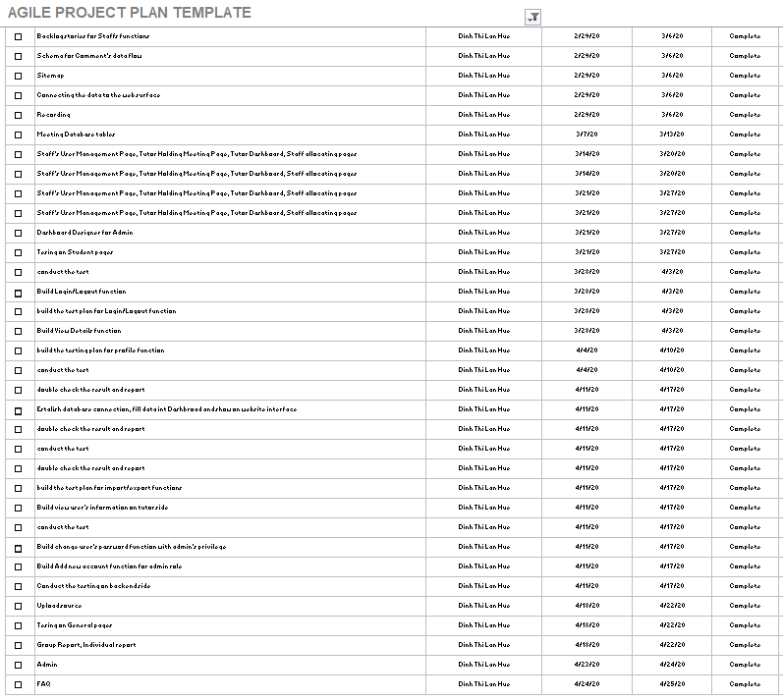

Figure 2: Agile Project Plan Template - Dinh Thi Lan Hue

This is for Mr. Trung

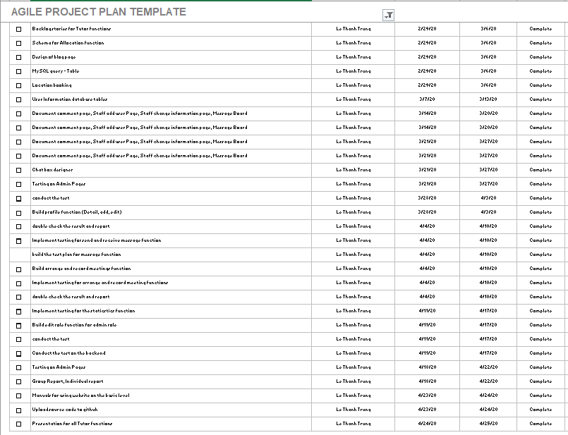

Figure 3: Agile Project Plan Template - Le Thanh Trung

This is for Mr. Thong

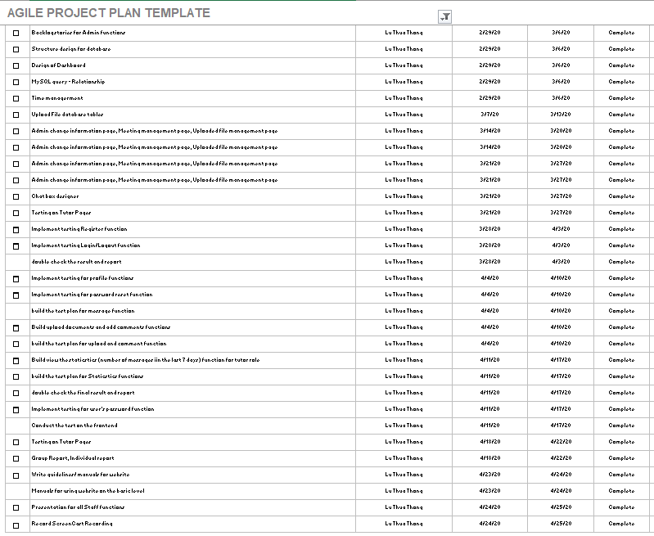

Figure 4: Agile Project Plan Template – Lu Thua Thong

This is for Mr. Hieu

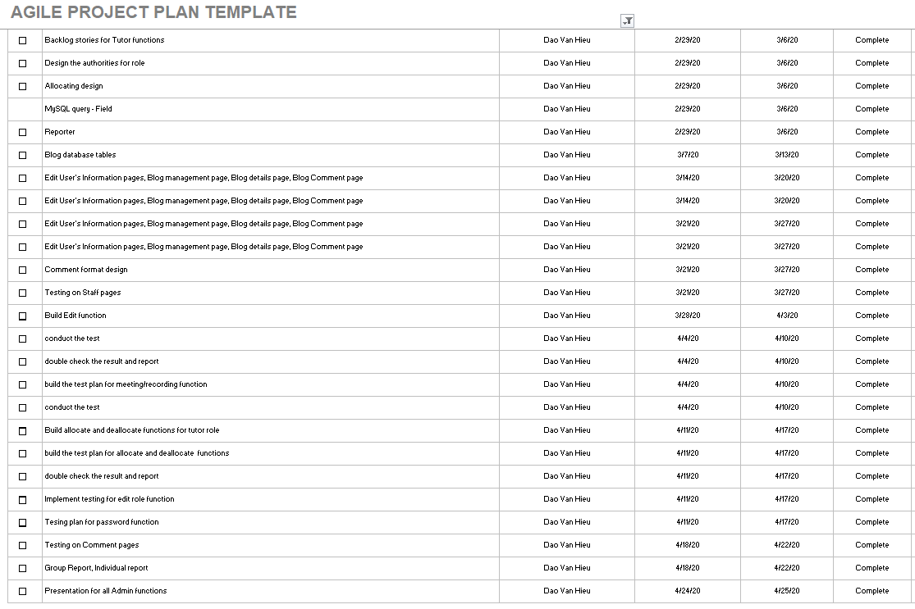

Figure 5: Agile Project Plan Template - Dao Van Hieu

And this is for Mr. Phong

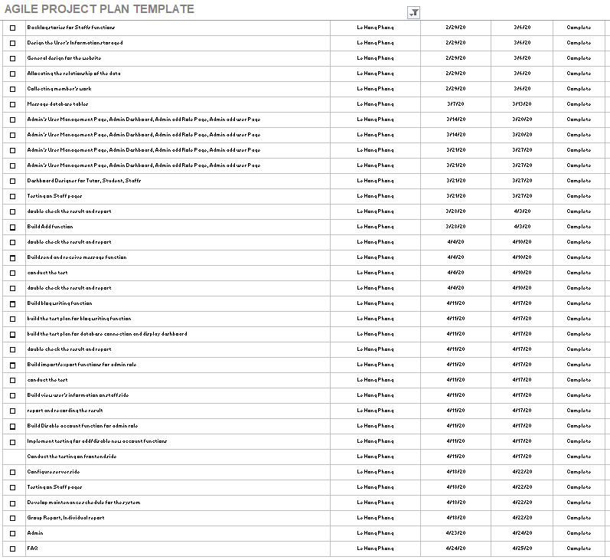

Figure 6: Agile Project Plan Template - Le Thanh Phong

Please check the files Sprint_Backlog and Daily_meeting for more information. The Figures used on this report are just the references. They are too small to be seen clearly close up.

# **Evaluation of product and process**

## Database Design Screen Shots

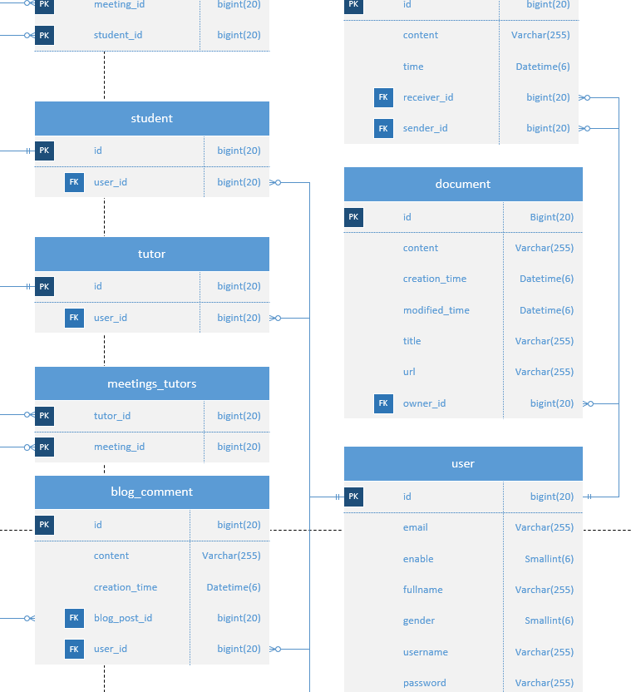

Figure 7: Database Design Example

The database was created to fit with the customer requirement. The hardest part is that I must collect the usage of the end users properly during this pandemic, because I can not hold any face-to-face meeting with them to have a proper talk. If the picture is too small, please visit file Visio “Database Design Visio” for more information.

## Interface Design Screen shot

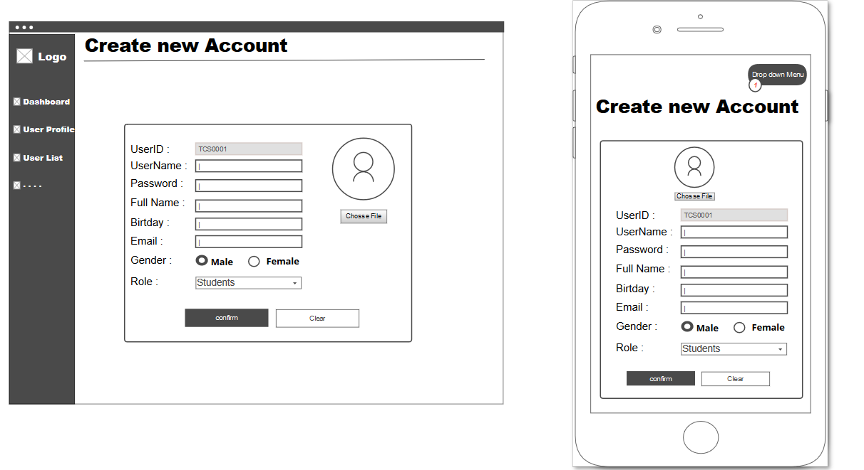

Figure 8: Mockup Example

For the Interface, I got my hand on design the Add Account Page for Staff, Static page, Allocating page, and general design of the whole web page (ex. The background, the position of the menu, the title ...

Due to the requirements of the customer, this is must be a responsive website, so that I will need to design 2 versions for each page as you can see above. A version of full-screen website, and a modified version for the devices that had small screen. Please check the Document of Group Report for better dataflow and full version of what I already done.

## Backend Coding

As said above, everyone on the team also take a part on development process, no matter what part it is, and for Backend coding this time, I am taking Upload Document Function and Import/Export Function.

Since Upload Document is just a function that up the whole file to the storage, I would like to present the Import/Export function instead since it had more coding with better understanding

### Upload Function

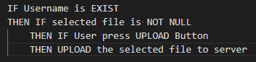

Figure 9: Upload Function

This function will simply check the slot of selected file first, if it is not NULL (contained a file) and user Press upload button, the system will simply upload the file into the server (in this case, is the folder)

### Export Function

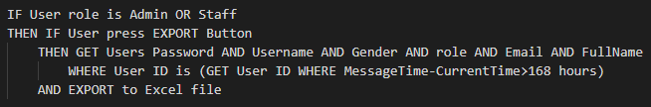

Figure 10: Export Function 1

This function has been placed in 2 different places, the first one is on Report Page, to extract the information of the exceptional student out of the system. The code about description about the way to check if the export function on exceptional report has been hit, any student that did not have any interact (send any message) will be put on the exported file

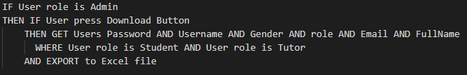

Figure 11: Export Function 2

Another export function is placed on Import/Export section, this export function just simply printout the information of all users whom role is Student.

### Import Function

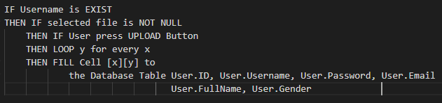

Figure 12: Import Function

And this is the simple import function code, to import the user data from the test file Cell by Cell to the suitable fields on database table User.

### Data Flow Explanation

First when the Admin or Staff click into the indicate to download the file, the system will run through all the record on the data to check the message with all the Sender is Student, and see the post time of those messages, find the latest message and then compare it to the current day on the user computer. If the day is far more than 7 days or 28 days, the system will trace back that message and fine the owner(s) and put the information of that user(s) in the excel file to export it outside.

# **How we process the current Project using Agile**

From what we followed during the who Project, First, the whole team will sit together and have a discussion about the Stakeholders Requirements. And then from that we can identify the User Stories, and get the right Product Back Logs.

After getting the Product Back Logs, we can plan the road map outs and identify the Sprint Planning meeting. Of course, everything is still just a plan, it can be changed later on if needed to flexible fit with the situation.

A Sprint Backlog with all the task has been breakout to many small parts will be given out to the members of the team, each Sprint will last 2 weeks with the set number of goals for each member on the team. Me and Mr. Phong will record the works once every single day of working, and plan out the Daily Scrum Meeting. But due to the Covid-19 pandemic, we cannot afford to meet up every day, that is why we only have one Daily Scrum Meeting every week – being said, “a week” in my team language is equal to the hours of a full day of working thou, so it also can be counted as “daily” meeting –

The finished works of a week will be delivery to customers right away to get the feedbacks from them and also the funding for the following week. In this way, we can follow the principles of Agile to it fullness.

# **Evaluative the product**

For the general grade, I would like to grade my team product at 9 out of 10. The 1 minus point is come from some functions that had a lot of bug during the building time, some of them being mess up with each other and then the old bugs appear, make it really hard to test through all of them.

For example: The menu of the Staff Role, instead of fixing it as my suggestion, the developer of this function decide to take a short way and make it look the same with Admin menu, and then another bugs arise, now a Staff can easily delete the Admin account, or assign a student to become Admin, or Delete the other Staff account as his free wills, and it is really depressing when just the way to fix bug will leads to another ton of potential security bugs.

Beside that poor done fixing, I am pretty impressive with the working pace of our team, everyone took it really seriously and trying really hard to keep the communication in touch, it is specially really beneficial for me, a person with almost no background on working of the group.

## Evaluative the Agile process

On what me and my team experience, Agile process – Scrum has many advantages that may fit for the medium and small projects. The development team will spend a lot of time to meet up with the customers (almost one meeting every Saturday in my case). All the feedbacks will be put into consider when develop the product, not only that, it also help reduce the financial risk that the developers usually carry because the project has been broken down to many other small part, and there is a clear plan which will be delivery out when it come to the end of the week to identify and estimated the payout step by step (continuous methods). The team is also can work more efficiency due to that broke down, they can divide the work eventually and then finish them, then they can help the others on their part as well.

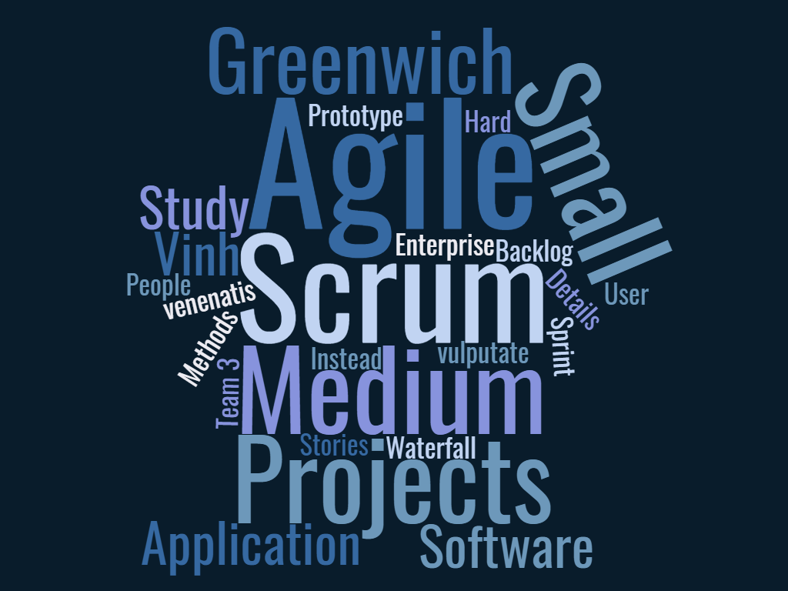

Figure 13: Agile Scrum method

### Personal unsatisfied points of view

I myself feel that distributed the work vastly for everyone in the team is not a good ideal, since the strength and weakness of each person is different, we can not expect them to be good at everything. For Example: Some people may be really good at backend coding, but being force to play a part on Frontend design and coding, and then end up screw it up. Not only that the whole team must spend time to help him fix the bugs, we also wasted our precious time resource of the project

### How to improve

One person must carry the most is two roles, for example: I am really good at Database design, I can take care of the Database Design part, and also the Tester role that involve a lot of testing the database. Not only I can carry out the work in professional manner, but also, I will finish the tasks really quickly, and have spare time to help other people on the team with their parts.

# **Evaluation of Team**

For team evaluation, because it is a team with six members, that will be better if I put it on a separate with fully analyze to help clean out the strengths and weakness of each person.

|  |  |  |  |  |  |  |  |
| --- | --- | --- | --- | --- | --- | --- | --- |
| ***FACTOR*** | ***WEIGHT*** | ***Mr. Trung*** |  | ***Mr. Phong*** | ***Mr. Hieu*** | ***Ms. Hue*** | ***Mr. Thong*** |
| ***Attendance*** | 5 | 5 |  | 5 | 5 | 10 | 10 |
| ***Timekeeping*** | 10 | 5 |  | 10 | 5 | 8 | 4 |
| ***Risk Analysis*** | 10 | 8 |  | 8 | 7 | 8 | 5 |
| ***Adapt*** | 10 | 10 |  | 10 | 7 | 10 | 10 |
| ***Code Skill*** | 5 | 5 |  | 10 | 9 | 8 | 5 |
| ***Engage*** | 5 | 10 |  | 10 | 10 | 10 | 10 |
| ***Criteria*** | 5 | 10 |  | 10 | 10 | 10 | 10 |
| ***Teamwork*** | 10 | 8 |  | 7 | 7 | 6 | 10 |
| TOTAL | 60 | 7.7 |  | 8.8 | 7.2 | 8.5 | 7.8 |

|  |  |
| --- | --- |
| PERSON | TOTAL |
| Mr. Trung | 7.7 |
| Mr. Phong | 8.8 |
| Mr. Hieu | 7.2 |
| Ms. Hue | 8.5 |
| Mr. Thong | 7.8 |

Figure 14: Factor Comparison

It is not like everyone have a good attendance, at this area, I think there is no way our team can improve it, since all of our members must work overtime regularly and had packed schedule. But evaluate score is still a score, and I do not want to overlook it and become bias, so, this is it.

Of course, when the attendant being a problem, another field such as Timekeeping and Risk Analysis also have the impact on it. There is nothing we can do to improve it anyway. But I do think if they do not have a job right now, they can improve it significantly, but it is a no, we can not wish someone to lose their job over some school project, right?

Another aspect of the Grade system is Code Skill, I do not know why, but Mr. Trung and Mr. Thong is not that good at coding compare to Mr. Phong or Mr. Hieu. Mr. Trung and Thong should have taken another java coding class to improve their coding skill so that they can help more in future project.

# **Self-Evaluation**

For the Self-Evaluation, since the project being choose to write in Java, the language that I do not have much influence in, it is really hard for me to both learn the way to adopt the Agile and write code at the same time, so If I can grade myself for the Adapt curve, it should be only around 6. The coding skill is also at 6 – I should learn another java course to improve that, but apparently, I am fond into C# rather than Java, it will take a time to consider the course of action in this time.

For both Engage and Attendant I am confident to have it at 10, also the risk Analysis should stand at 9 since I will be the one who mainly design the Database – the very foundation work that will affect the whole project later on – and the project work really well right now so I suppose that my Risk Analyze must be this high at least.

For Teamwork, I think I can achieve at least around 6, thank to Mr. Trung and Mr. Thong. If I have more time, I can learn more from them.

The lesson I learnt from this project may become the first experience when I tried to switch the industry from business to computer science, in business I work alone most of the time, because if any, I said any, of the people around you aware of what are you trying to do, no one can say what will they plot against you. But for computer science, everyone just work as a team, helping each other to move forward together, and this is a really big change to open my mind, it is a life lesson I think, the mindset is always the mindset, you can not just get one and force it to everywhere.

# **SCREENCAST & PRESENTATION**

* Link Slide giới thiệu sơ về toàn bộ dự án
* Link Đoạn quay phim đang screen cast + đưa ra 1 file riêng để gửi riêng cho trường
* User Guide cho phần cá nhân làm (hướng dẫn dùng bằng hình ảnh) + đưa ra 1 file riêng để gửi riêng cho trường

# **LOCATION REPOSITORY**

* Link để download toàn bộ bài